**1.** Analyze the given counter and plot the wave form depend on CLOCK pulse (at least 8 CLOCK pulse).

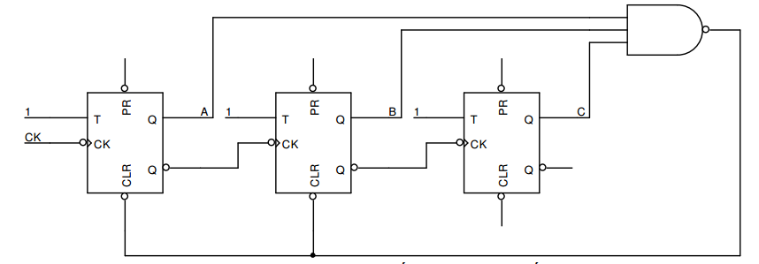

**2.** Build the excitation and plot the state diagram of the counter below.

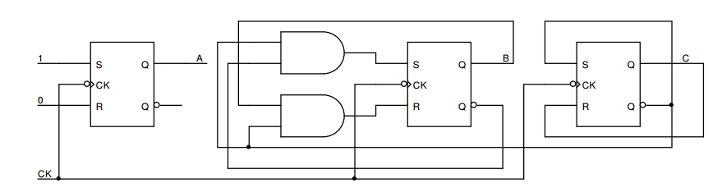

Is this circuit being able to self-working?

**3.** Give the logic circuit below:

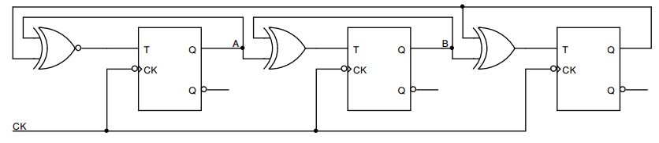

a) Implement input function for each FF.

b) Describe how the circuit works?

**4.** The function F has 4 variables A, B, C, D. The value of F is 1 if the decimal value of variables divides 3 or 5 without remainder, otherwise F = 0.

a) Implement F by using 2-input logic gate.

b) Implement F by using a MUX 8 to 1 and logic gates (if necessary).

c) Implement F by using a MUX 4 to 1 and logic gates (if necessary).

d) Simplify F and implement F using the Half-Adders.

**5.** Design a logic circuit that counting depend on input control P. If P = 1 the circuit count $0→1→3→5→7→1$ and when P = 0 the circuit count $0→2→4→6→2$.

a) Using JK FF.

b) Using T FF.